W. 45 Introduction to ”English speaking countries project”
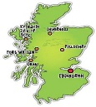
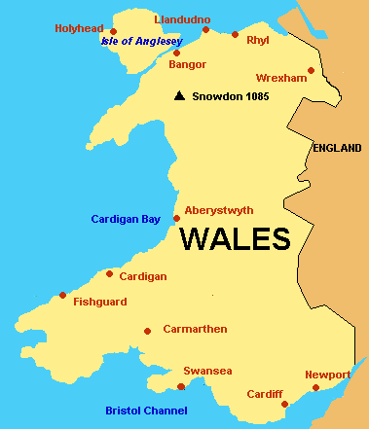
What? This week you will get to know Scotland and Wales which will provide you with exercises that will help you to develop skills that are necessary when working with English speaking countries. These skills are ;

- To be able to use spoken English (news, documentaries, films etc.) in your own production using your own words
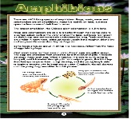
- To be able to use different English texts (news, articles, factual texts etc.) in your on production using your own words.
Monday/Tuesday Thursday
1. Listen to James MacDonald from Scotland and Siân Williams from Wales.  2. Write down notes in your notebook  3. Rewrite the information in sentences in your notebook  4. Do exercise 1, 2 and 3 while listening to:  http://www.newsinlevels.com/products/big-demolition-in-scotland-level-1/  5. 8 irregular verbs – let a friend check if you know how to use them in sentences | 1. Read about Scotland on p.30-31 in t.b  2. Do “After reading” p. 31 (exercise 1-2)  3. Now select important fact that you have learnt and write it in your notebook -Try to write keywords only!  4. Present the piece of fact you have got orally in pairs.  5. Do exercise 1, 2, 3 and 4 with “Welcome to Wales” on p. 32-33 in t.b
Extra: p. 152-153 in w.b →

Why? Working in groups with a project requires discipline and structure in many ways. Not only will you have to agree on who is doing what, you also need to make sure that you set up a goal for each lesson so that each goal/lesson takes you one step closer to being able to present your share of the project. Most importantly, you will have to use your own words throughout the work with English speaking countries, which means this intro is beneficial in order for you to feel confident while working with the project.

