8d - Torsdagens lektion - arbeta klart med det du inte är färdig med och dela med Sara i One drive/alternativt lägg skrivboken i mitt fack.

English Monday/Tuesday 14 -15/9 English Thursday 24/9
- Work in pairs. Discuss the examples of challenges on p. 12 in t.b.  - Rank the challenges 1-10 i your notebook (do this individually, which is the most challenging situation?  - Compare the list with your friend.  - Write 7 sentences in your notebook using all the words from the green section (glossary list) on p.12 in t.b  - Take turns describing the words (glossary list) to your friend (without saying the word) and he/she will guess what word it is. (Orally)  EXTRA:  Write a dialogue about p. 13 in your t.b. Present it to your teacher.  - What are they talking about?  - What is their challenge, according to you?  - How will they overcome the challenge? | - Watch Steve Irwin on youtube. (approx. 10 min.)  - Discuss the questions written on the whiteboard in pairs.  - Read p. 14-15 in your t.b.  - Do p. 7-9 in your w.b (exercise A-E).  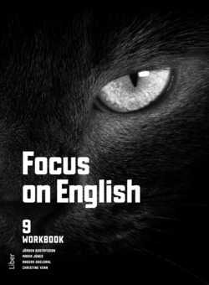  HOMEWORK FOR  MONDAY/TUESDAY  Pick minimum 10 words from  p. 14-15 in t.b. (Grade E)  (Green section) + borrow an  English novel.

